Experiment 1.1
Algorithm to Find Area of a Circle
Step 1: Start
Step 2: Read radius r
Step 3: Area = 3.14 × r. × r
Step 4: Display area
Step 5: Stop

Flowchart:
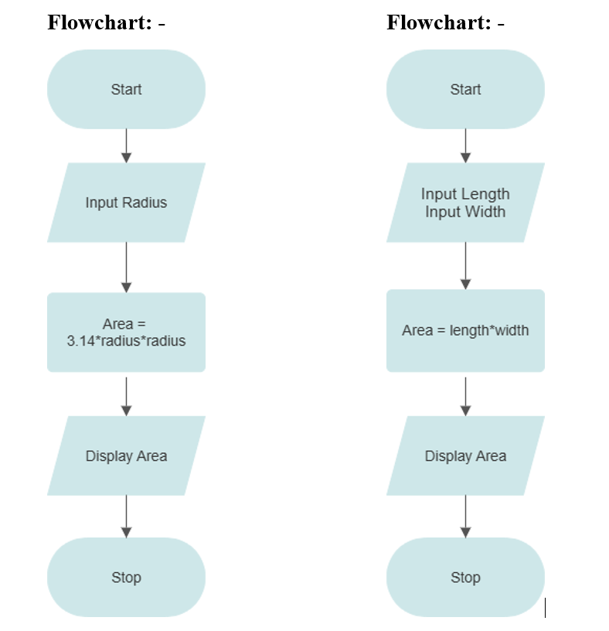
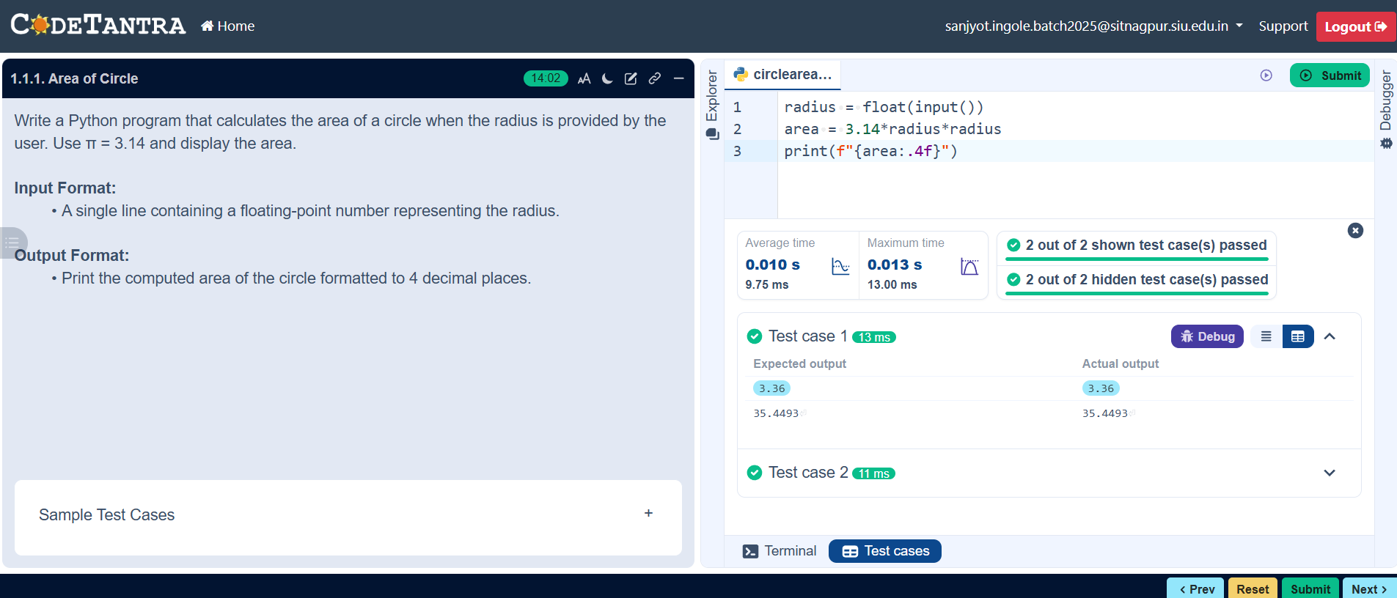

Experiment 1.2 :
Algorithm to Find Area of a Rectangle

Step 1: Start
Step 2: Read length and width
Step 3: Area = length × width
Step 4: Display area
Step 5: Stop
Flowchart:

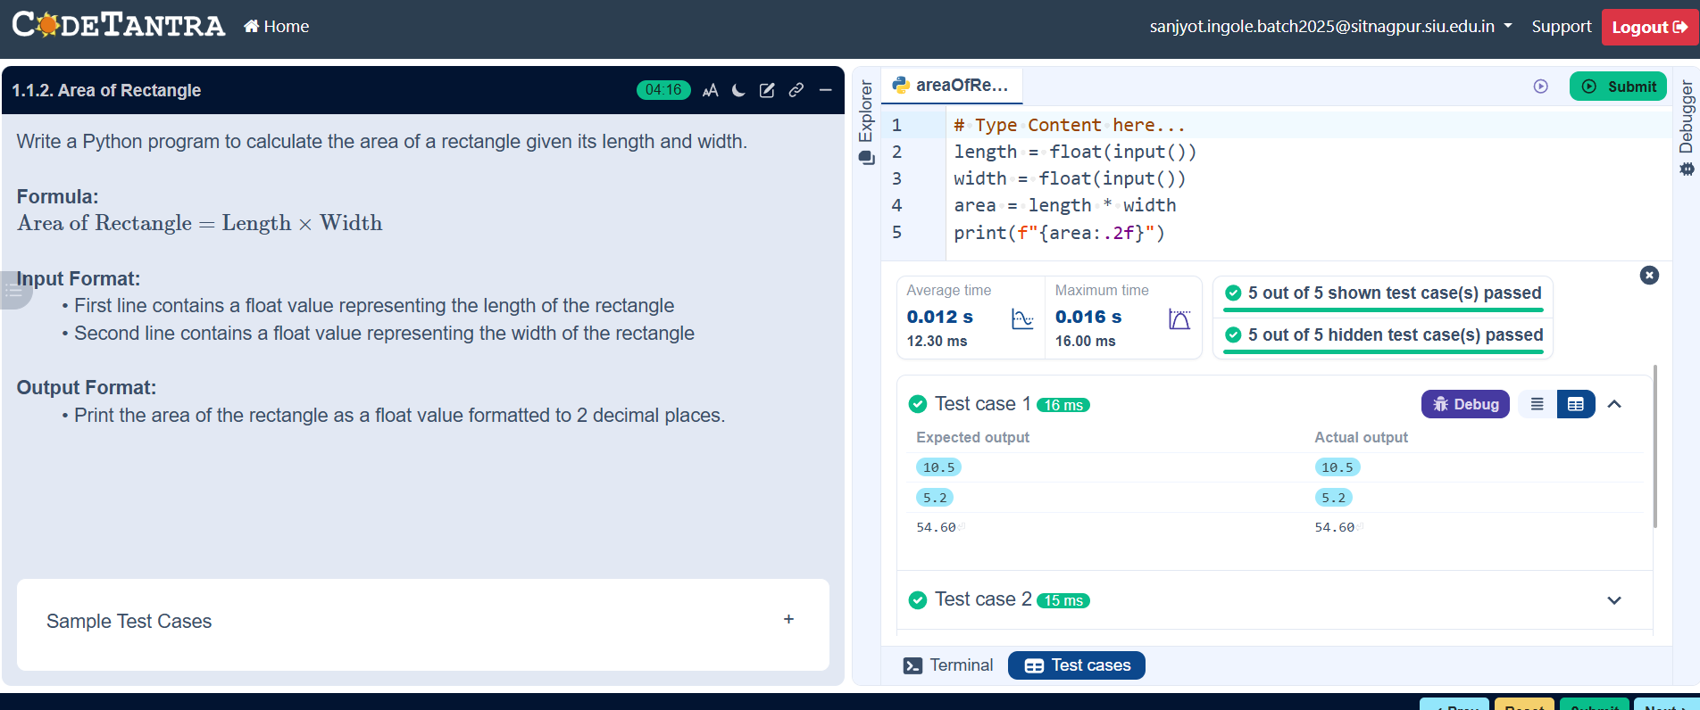

Experiment 1.3
Algorithm to Find Area of a Square
Step 1: Start
Step 2: Read side_length
Step 3: Area = (side_length)²
Step 4: Display area
Step 5: Stop

Flowchart:
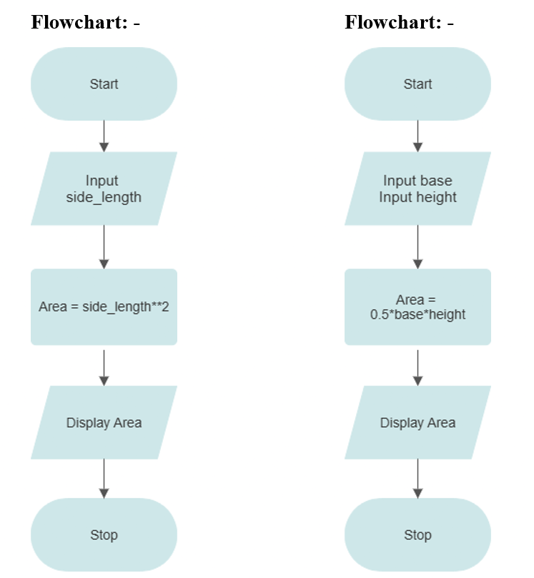
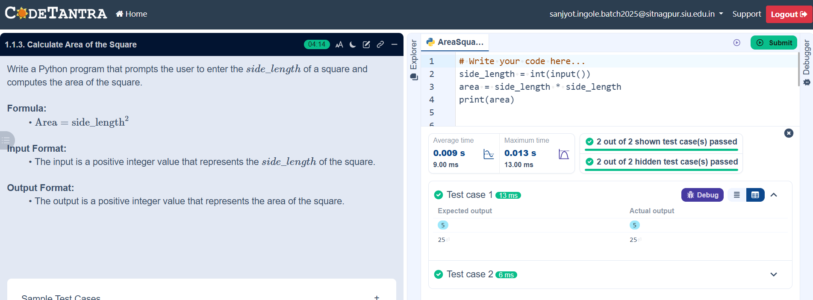

Experiment 1.4
Algorithm to Find Area of a Triangle
Step 1: Start
Step 2: Read base and height
Step 3: Area = ½ × base × height
Step 4: Display area
Step 5: Stop

Flowchart:
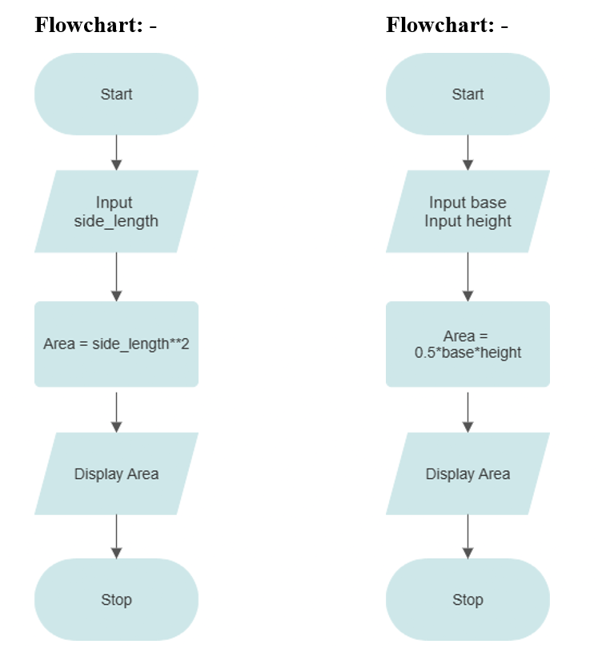
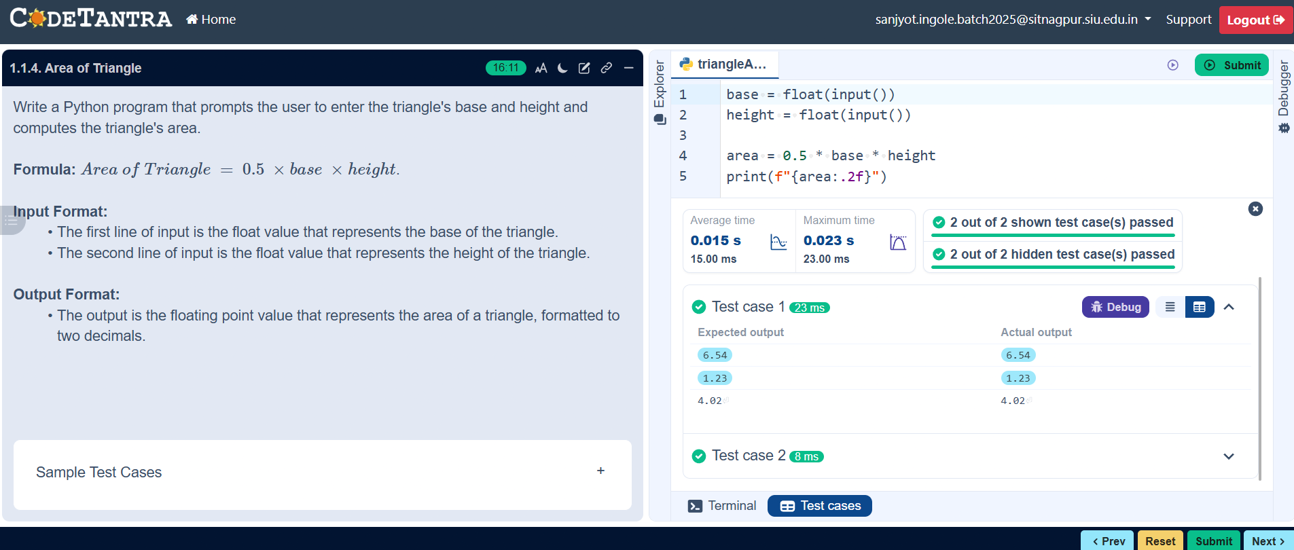

Experiment 1.5
Algorithm to Determine Whether a Student Passed the Exam or Not
Step 1: Start
Step 2: Read marks
Step 3:
- If marks ≥ 40, display PASS
- Else, display FAIL
Step 4: Stop
Flowchart:
